Koby Miller

Section number: 11207

Assignment number: 3

Date due: 2/6/2020

**ER Diagram**

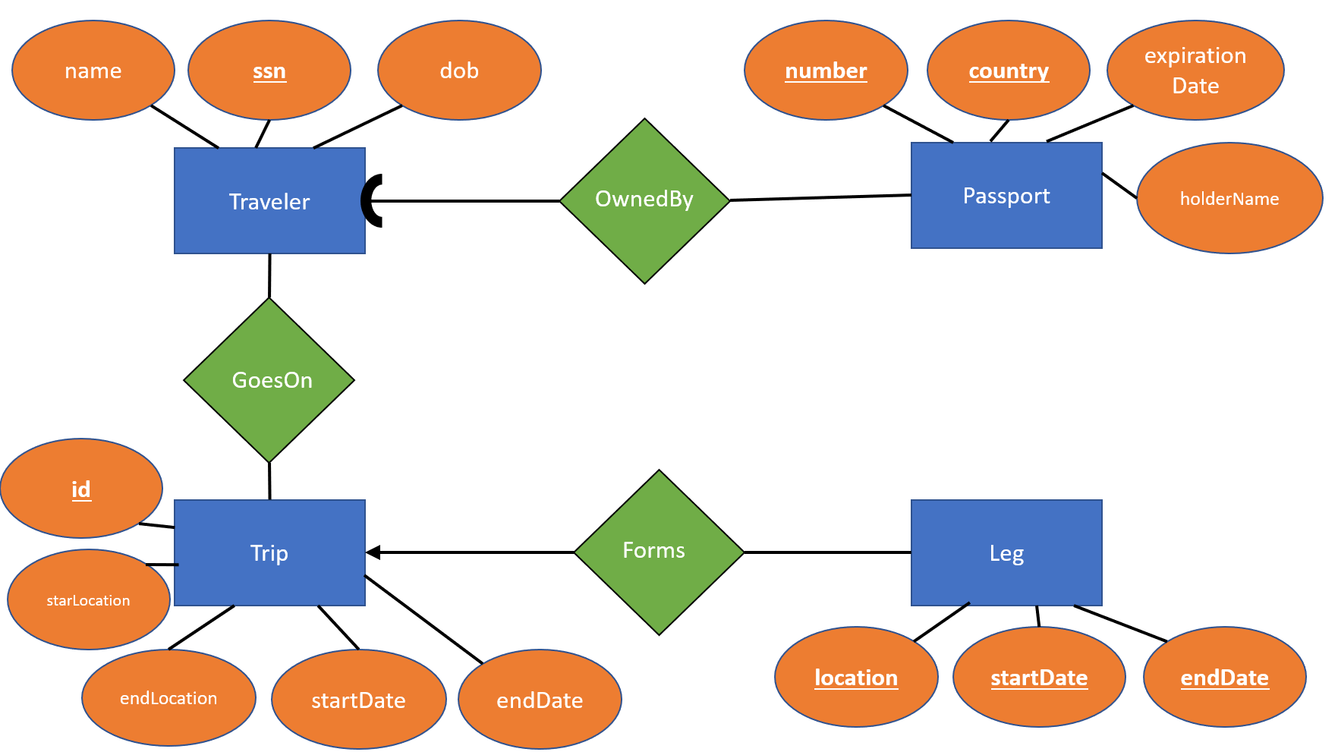

Relational Data Model

